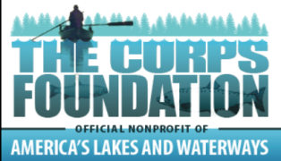
U.S. Army Corps of Engineers
Excellence in Partnerships Award
2015 Nomination Application

Please review instructions before completing application!

Corps project name:
Corps point of contact:
Partner’s name:
Partner’s point of contact:
Corps Project mailing address:
Corps Project phone number: - -

Describe the nominee’s accomplishments using the below criteria.
- Creativity and Originality. The nominee has shown creativity and originality in serving the public and assisting the Corps in meeting the needs of its customers:

- Improvement in Public Awareness/Education. Enhancing the public’s awareness of the Corps Recreation and/or Environmental Stewardship missions. Providing members of the public with significant opportunities to acquire the knowledge, values and attitudes related to Corps projects and public lands in general:

- Accomplishment of Management Objectives. Accomplishing management goals and objectives and has assisted the Corps in accomplishing work items that could not have been accomplished without the partnership:

- Involving Other Partners. The partnership has increased community involvement and understanding of the Corps role in serving the Nation:

- Serving Diverse Audiences. The partnership has strengthened and improved the Corps ability to provide good customer service by developing programs that are accessible and sensitive to the needs of diverse user groups. Diversity may include but is not limited to ethnicity, people with disabilities, various socioeconomic backgrounds, or a variety of recreation user groups:

Citation. Provide a summary of achievements/proposed citation that may be read at the award ceremony

